## FINANCE RECEIPTING USING ROBOTIC PROCESS AUTOMATION

## A PROJECT REPORT

***Submitted by,***

**HEMA B - 20211ISR0006**

**BHARATH MANOHAR S - 20211ISR0025**

**RAKSHITHA K - 20211ISR0063**

**AISHWARYA C - 20211ISR0068**

**KRUTHIKA S - 20211ISR0085**

### *Under the guidance of,*

**Ms. Smitha S P**

***Assistant Professor***

***in partial fulfillment for the award of the degree of***

**BACHELOR OF TECHNOLOGY**

**IN**

**INFORMATION SCIENCE AND ENGINEERING**

**(ARTIFICIAL INTELLIGENCE AND ROBITICS)**

**At**



**PRESIDENCY UNIVERSITY**

**BENGALURU**

**January 2024**

**PRESIDENCY UNIVERSITY**

**SCHOOL OF COMPUTER SCIENCE ENGINEERING**

**CERTIFICATE**

This is to certify that the Project report **“FINANCE RECEIPTING USING ROBOTIC PROCESS AUTOMATION”** being submitted by “Hema B, Bharath Manohar S, Rakshitha K, Aishwarya C, Kruthika S” bearing roll number(s) “20211ISR0006, 20211ISR0025, 20211ISR0063, 20211ISR0068, 20211ISR0085” in partial fulfillment of the requirement for the award of the degree of Bachelor of Technology in Information Science and Engineering is a bonafide work carried out under my supervision.

|  |  |
| --- | --- |
| **Ms. Smitha S P**  Assistant Professor  School of CSE&IS  Presidency University | **Dr. Zafar Ali Khan**  Professor & HOD  School of CSE&IS  Presidency University |

|  |  |  |
| --- | --- | --- |
| **Dr. L. SHAKKEERA**  Associate Dean  School of CSE&IS  Presidency University | **Dr. MYDHILI NAIR**  Associate Dean  School of CSE&IS  Presidency University | **Dr. SAMEERUDDIN KHAN**  Pro-VC School of Engineering  Dean -School of CSE&IS  Presidency University |

**PRESIDENCY UNIVERSITY**

**SCHOOL OF COMPUTER SCIENCE ENGINEERING**

**DECLARATION**

We hereby declare that the work, which is being presented in the project report entitled **FINANCE RECEIPTING USING ROBOTIC PROCESS AUTOMATION** in partial fulfillment for the award of Degree of **Bachelor of Technology** in **Information Science and Engineering**, is a record of our own investigations carried under the guidance of **Ms. Smitha S P, Assistant Professor,** **School of Computer Science Engineering & Information Science, Presidency University, Bengaluru.**

We have not submitted the matter presented in this report anywhere for the award of any other Degree.

|  |  |  |
| --- | --- | --- |
| **Name** | **Roll No** | **Signature** |
| **Hema B** | **20211ISR0006** |  |
| **Bharath Manohar S** | **20211ISR0025** |  |
| **Rakshitha K** | **20211ISR0063** |  |
| **Aishwarya C** | **20211ISR0068** |  |
| **Kruthika S** | **20211ISR0085** |  |

**ABSTRACT**

The subject of this project is the utilization of UiPath for the application of RPA in transforming the finance receipting process. Current traditional ways of handling financial receipts, including data entry, population of templates, and dispatch by email, are labour-intensive, prone to errors, and inefficient when applied to the processing of very high volumes of transactions for most businesses. This project will meet the above requirements by streamlining and standardizing the end-to-end receipting workflow with an all-inclusive automation solution. The RPA solution begins with extracting transactional data from an Excel file comprising receipt numbers, customer information, and payment amount. The details are automatically fed into a template for the generation of credit card receipts. As a consequence, the resultant receipts are all the same as they are from a template; each resultant receipt is then stored as a unique file, separately organized in folders under a unique business-specific naming convention. Ultimately, the process of email dissemination is automated by the system attaching the correct receipt to the email that is sent directly to the email address of the customer.  
  
The key goals of the project involve operational efficiency, lower human error, and higher scalability. The process time for processing is highly reduced through a significant increase in automation, thus enabling large transaction volumes to be handled with minimal intervention from humankind. The error-handling capabilities are strong, making sure the reliability of the system is guaranteed as missing data or a wrong email address is logged for review. The project also allows employees to free up time for higher-value work, thereby boosting overall productivity by eliminating repetitive tasks. The outcomes of this project demonstrate the transformative potential of RPA in financial workflows. Businesses enjoy timely and accurate receipting, improved customer satisfaction, and reduced operational costs. The system is scalable and adaptable to accommodate any future changes in templates, data formats, or business requirements. This implementation shows how automation can optimize back-office financial operations with a secure, efficient, and future-ready solution for receipting tasks.

**ACKNOWLEDGEMENT**

First of all, we indebted to the **GOD ALMIGHTY** for giving me an opportunity to excel in our efforts to complete this project on time.

We express our sincere thanks to our respected **Dr. Md. Sameeruddin Khan**, Pro-VC, School of Engineering and Dean, School of Computer Science Engineering & Information Science, Presidency University for getting us permission to undergo the project.

We express our heartfelt gratitude to our beloved Associate Deans **Dr. Shakkeera L and Dr. Mydhili Nair,** School of Computer Science Engineering & Information Science, Presidency University, and **Dr. “Zafar Ali Khan**”, Head of the Department, School of Computer Science Engineering & Information Science, Presidency University, for rendering timely help in completing this project successfully.

We are greatly indebted to our Guide **Ms. Smitha S P,** **Assistant** **Professor** and Reviewer **Dr. Afroz pasha, Professor,** School of Computer Science Engineering & Information Science, Presidency University for his/her inspirational guidance, and valuable suggestions and for providing us a chance to express our technical capabilities in every respect for the completion of the project work.

We would like to convey our gratitude and heartfelt thanks to the PIP2001 Capstone Project Coordinators **Dr. Sampath A K, Dr. Abdul Khadar and Mr. Md Zia Ur Rahman,** department Project Coordinators **Dr. Afroz pasha** and Git hub coordinator **Mr. Muthuraj.**

We thank our family and friends for the strong support and inspiration they have provided us in bringing out this project.

**Hema B  
Bharath Manohar S   
Rakshitha K  
Aishwarya C**

**Kruthika S**

**TABLE OF CONTENTS**

|  |  |  |
| --- | --- | --- |
| **CHAPTER NO.** | **TITLE** | **PAGE NO.** |
|  | **ABSTRACT ACKNOWLEDGMENT** | **iv**  **v** |
| **1.** | **INTRODUCTION** | 1 |
| **2.** | **LITERATURE REVIEW** | 2 |
| **3.** | **RESEARCH GAPS OF EXISTING METHODS** | 4 |
| **4.** | **PROPOSED METHODOLOGY** | 7 |
| **5.** | **OBJECTIVES** | 19 |
| **6.** | **SYSTEM DESIGN & IMPLEMENTATION** | 20 |
| **7.** | **TIMELINE FOR EXECUTION OF PROJECT (GANTT CHART)** | 40 |
| **8.** | **OUTCOMES** | 41 |
| **9.** | **RESULTS AND DISCUSSIONS** | 42 |
| **10** | **CONCLUSION** | 43 |
|  | **REFERENCES** | 44 |

# LIST OF TABLES

|  |  |  |  |
| --- | --- | --- | --- |
| **Sl. No.** | **Table Name** | **Table Caption** | **Page No.** |
| 1 | Table 2.1 | Literature Review | 2-4 |

**LIST OF FIGURES**

|  |  |  |  |
| --- | --- | --- | --- |
| **Sl. No.** | **Figure Name** | **Caption** | **Page No.** |
| 1  2  3  4  5  6  7  8  9  10 | Figure 1.1  Figure 2.1  Figure 3.1  Figure 4.1  Figure 4.2  Figure 4.3  Figure 4.4  Figure 4.5  Figure 4.6  Figure 4.7 | Flowchart of Recommendation System  System design and implementation  Project Timeline  Student Course Login Portal  Faculty Login Portal  Head Of Department Portal  Student Portal.  Faculty Portal  HOD Portal  HOD Portal (2) | 21  25  49  50  51  52  53  54  55 |

**CHAPTER-1**

**INTRODUCTION**

Financial receipting is one of the most significant aspects of any business, more so for an organization dealing with a large number of transactions. It includes transaction data recording, accurate receipt creation, systematic filing, and proper delivery to the customers. In the past, this workflow relied solely on manual processes, which included employees doing all the data entry, populating templates, managing file storage and communication. While this is quite sufficient for businesses with small transaction volumes, it becomes quite inefficient and prone to errors when the scale of operations increases. Most common problems are delayed processing, lost records, or inaccuracies in data entry that can disrupt workflow and affect customer satisfaction.

The current business landscape is characterized by increasing demand for efficiency, accuracy, and scale in financial activities. Financial receipting procedures remain laborious with a likelihood to be erroneous by human mistakes leading to inconsistency in the account and late information to customers about their dealings.. This inefficiency makes clients dissatisfied and results in compliance risks that may occur whenever sensitive information belonging to the client is used as in credit cards and records of transactions.

It leads to addressing the key challenges it poses. Robotic Process Automation is a transformative approach to solving such challenges. RPA leverages software bots in replicating human actions for full automation of repetitive, rule-based tasks in high accuracy and speed. Thus, in this case, even the entire workflow regarding financial receipting can be completely automated-from pulling out the data about transactions on an Excel sheet to populating receipt templates and organizing files systemically to e-mailing them to the customer. This prevents manual intervention thus receipting, consistent, accurate, and in a timely fashion.

Therefore, this project is in the form of implementation of an RPA solution, which has the use of UiPath as it automates the process of a finance receipting process. Within the proposed solution, it shall extract information from structured Excel files and use extracted details to complete, dynamically a predefined template of credit card receipts; save resultant receipts in structured folder environment before sending them by way of e-mails to the clients. Through this automation, it expects to shorten processing time; accuracy of the data will enhance its operational efficiency.

**CHAPTER-2**

**LITERATURE SURVEY**

|  |  |  |  |  |  |
| --- | --- | --- | --- | --- | --- |
| **Study** | **Objective** | **Methodology** | **Tools/Technologies** | **Challenges Identified** | **Results/Findings** |
| Awasthi et al. (2023) | To automate invoice  creation and  processing for financial workflows | Leveraged robotic process automation to  extract structured data from  enterprise  systems like SAP and generate invoices automatically | UiPath, Python scripts for custom automation, SAP | Difficulty in addressing system  compatibility  issues and managing exceptions | Achieved a 70% reduction in  processing time  while maintaining accuracy |
| Williams &  Brown  (2023) | Simplifying financial  receipt  handling with  RPA | Developed automated  workflows for  data segregation and transaction classification | UiPath, OCR for text recognition, SAP for data  extraction | Managing exceptions  arising from  non-standard inputs | Achieved streamlined  operations with 85% error reduction |
| Patel et al. (2023) | Digital transformation in financial receipting processes | Automated  routine tasks  using pre-defined business rules | Automation Anywhere,  SAP connector, Email automation tools | Complexity in integrating with older  systems and  handling manual  paper-based inputs | Improved overall process efficiency by  75% |
| Lin &  Zhang  (2022) | Developing an automated system for generating and | Utilized rulebased automation with some machine learning | Blue Prism, OCR for data extraction, SMTP for email delivery | Challenges in designing workflows for diverse | Improved operational  efficiency by 80% and reduced human |

|  |  |  |  |  |  |
| --- | --- | --- | --- | --- | --- |
| Study | Objective | Methodology | Tools/Technologies | Challenges Identified | Results/Findings |
|  | delivering payment receipts | features for exception management |  | payment  types and templates | errors |
| Jones et al. (2022) | Automating financial  receipt  handling and delivery | Designed a comprehensive RPA workflow to handle data extraction,  processing, and email  notifications | UiPath for automation, integrated SMTP for email handling | Managing exceptions in processing  and ensuring email  delivery reliability | Successfully automated 85% of the processes with  robust exception handling |
| Das et al. (2022) | End-to-end automation of receipt  generation workflows | Developed an  RPA framework for retrieving  data, segregating records, and  generating receipts | UiPath, custom template generation scripts, OCR  tools | Difficulty in managing exception cases and ensuring uniform  template formatting | Delivered consistent performance with an  80% automation rate |
| Park et al. (2021) | Automation of finance-related  administrative tasks | Employed RPA solutions to manage  structured and  semi-structured data | Automation Anywhere,  OCR for document handling, File Server for storing templates | Reliance on precise  template  mapping and addressing  unstructured data issues | Reduced manual  workload by 60% and increased scalability |
| Singh &  Verma  (2021) | Improving efficiency in financial  workflows through automation | Implemented a rule-based  automation  system for  structured data processes | Blue Prism, File Server for storage, Email automation | Managing workflow  changes due to evolving rules and templates | Enhanced workflow efficiency and  reduced manual errors by 75% |
| Roy et al. (2021) | Enhancing back-office  productivity with RPA | Designed workflows for automating  repetitive tasks such as data  extraction and emailing | Blue Prism, OCR software for structured data extraction, File  Server for centralized template access | High exception  rate in cases of  incomplete  or erroneous data | Reduced processing time significantly  with minimal manual intervention |
| Chen et al. (2020) | Automating receipt mailing  processes for vendors | Created rulebased automation integrated with  email services to send receipts | Automation Anywhere, SMTP, and SAP | Addressing template  mismatches  and ensuring accurate email delivery | Achieved over 90% automation with  improved customer satisfaction. |
| Sharma & | Streamlining | Created | Blue Prism for | Challenges | Achieved significant |

|  |  |  |  |  |  |
| --- | --- | --- | --- | --- | --- |
| **Study** | **Objective** | **Methodology** | **Tools/Technologies** | **Challenges Identified** | **Results/Findings** |
| Kumar (2020) | cheque  processing and receipt generation | workflows based on conditional  logic to segregate  data and generate receipts for various  transaction types | automation, OCR for  reading cheque details,  SAP integration | in processing handwritten  cheques and  ensuring data accuracy | time savings and  enhanced accuracy in cheque handling |

**Table 2.1**

**CHAPTER-3**

**RESEARCH GAPS OF EXISTING METHODS**

**Manual Data Entry and Receipting**

Manual data entry and receipting is one of the oldest and most straightforward methods of managing financial transactions. This method involves extracting information from sales or transaction records such as customer details, transaction IDs, payment amounts, and dates, which are then entered into a predefined receipt template. Employees have to fill in the receipt form by hand, and then this can be printed for delivery or saved as a digital file and emailed to the customer. It is a common practice of small businesses or organizations that have fewer transactions because it requires less technological infrastructure. Usually, templates are prepared with more flexibility and personalization options through Microsoft Word or PDF editors. The process, however, is highly manual, and it involves numerous inefficiencies. The employees have to look after each transaction on their own, making the process even more error-prone due to wrong data entry or missing information. In addition, each receipt's completion time also presents a limit for scalability of the process and has become less tenable for most growing businesses that deal with many transactions. Even with all its inadequacies, manual data entry is still preferred in small business activities since its simplicity is paired with low costs for implementation. Most businesses using this procedure opt to embrace flexibility rather than the efficiency and entrust the assessment of rare transactions to human instinct.

**Excel-Based Receipting**

Microsoft Excel is largely used by various businesses to take care of all transaction data. It organizes data into tables, which, in turn helps businesses keep efficient records of the transactions. This can be accomplished by creating receipts in Excel through manually or partially automated entry for receipt numbers, customer names, and payment amount. Basic calculations are easily performed and simple tasks can be automated with built-in formulas for Excel-based receipting. Businesses can calculate totals, taxes, or discounts with formulas in Excel, thus avoiding mathematical errors often found when working manually. Use of Excel provides data sort and filter that also increases the retrieval probability of a particular transaction if it needs to be accessed from time to time.

**Macro Automation in Excel**

This essentially acts as a repetitive task in which macros can run automatically in Microsoft Excel to give a more significant efficiency in their receipting exercise. Macros run a series of actions, either filling out some transaction data through a receipt template or formatting different cells, into an automatic workflow with a click of a single command. Macro usage is great for businesses involving similar types of transactions and ensuring consistent formatting requirements in receipts.

For instance, a macro can be written to pick the transaction information from an Excel sheet's specific row and populate the details into a template receipt. It reduces manual labor required for data transfer and makes all receipts look alike. The macro can also automatically save files and assign a unique name for every receipt, perhaps using a combination of a transaction number and the customer name. The macro, while somewhat automated, does have its limits. Developing and maintaining macros requires knowledge of programming languages like VBA (Visual Basic for Applications). In addition, it is highly dependent on the structure of the data and templates. Hence, there is a potential failure if changes are made to the input format or workflow. Macros are likely to be not flexible enough to accommodate the change for businesses whose requirements are either complex or dynamic.

**Basic Accounting Software**

The most popular accounting software is QuickBooks, FreshBooks, and Xero, which have been widely used by businesses to automate financial tasks, including receipting. These programs make the receipting process much easier because they automatically generate receipts based on transaction data entered into the system. Using accounting software, business people can account for sales transactions while at the same time handling information relating to customers, which may then be used to generate receipts. This is an advantage of using accounting software: one can put together various processes related to the finances. If one makes a transaction in the system, automatically the software is able to give a receipt while updating the books and even printing it out as an email to the customer. Many accounting tools contain reporting features for businesses to enable them to gain insights from data about their transaction

**Email-Based Receipting**

Email-based receipting is the process of creating receipts manually or semi-automatically and then sending the respective receipts over email to the customers. Business can utilize platforms like Microsoft Word or PDF editors in order to create receipts, attach them to the e-mails, and send them over to the customers. The use of software solutions, with their support for email automation, will help to make this easier. For businesses, which have transactions of moderate quantity, email receipting is beneficial in communicating directly with customers and mailing receipts quickly. Some systems could automatically dispatch a mail on an email once the transaction is concluded, thus decreasing the time taken manually to send mail.

**Document Management Systems**

Document management systems (DMS) are used to store and organize digital receipts systematically. While these systems primarily focus on record-keeping, they are often integrated with receipting processes to ensure that receipts are automatically saved and categorized once generated.For example, a DMS can be configured to save receipts in specific folders based on transaction details such as dates, customer names, or receipt numbers. This improves the organization of financial records and simplifies retrieval during audits or customer inquiries.

**CHAPTER-4**

**PROPOSED METHODOLOGY**

**Methodology**

The methodology for this project is systematically organized into multiple stages, each tailored to ensure the effective implementation of a robust and scalable RPA solution for automating the finance receipting process. These stages—planning, requirement gathering, workflow design, development, testing, deployment, and integration—serve as a roadmap to transform traditional manual workflows into an automated system capable of handling repetitive tasks with precision and efficiency.

The process begins with planning, which establishes the foundation for the entire project by defining its scope, objectives, and expected outcomes. This stage ensures alignment with business goals and prepares a framework for subsequent steps. Following this, the requirement gathering phase involves a detailed analysis of the current manual receipting process. This includes identifying the structure of transaction data stored in Excel, understanding the fields and format of the receipt template, and defining key business rules such as file-naming conventions and folder structures. A thorough analysis of these elements helps in pinpointing inefficiencies and determining areas suitable for automation.

In the workflow design stage, the insights gathered are translated into a step-by-step blueprint for automation. This involves defining tasks such as reading transaction data from Excel, mapping it to corresponding fields in the receipt template, saving the completed receipts as organized files, and automating their distribution via email. A logical sequence is established to ensure the workflow operates seamlessly, with all processes integrated into a cohesive system.

The development phase focuses on building the automation workflow using UiPath Studio. This includes configuring data extraction, dynamic template population, automated file management, and email dispatch. Each component is meticulously developed to align with the design blueprint and tested individually to ensure functionality.

The workflow undergoes testing and validation to confirm its accuracy, reliability, and scalability. Simulated scenarios are used to test data extraction, template filling, file-saving, and email automation, ensuring that the system handles various conditions effectively. Robust error-handling mechanisms are integrated to manage issues like missing data or invalid email addresses.

Finally, in the deployment and integration phase, the validated workflow is implemented in a live environment. The system is connected to existing infrastructure, including email servers and shared folders, and scheduled to run at defined intervals based on business needs. Post-deployment, monitoring tools are employed to track performance metrics, and regular updates are applied to adapt to evolving requirements.

This structured methodology ensures the creation of a comprehensive and scalable RPA solution, delivering improved efficiency, accuracy, and reliability while significantly reducing manual effort and operational costs.

**1. Requirement Gathering and Process Analysis**

The foundation of the automation process begins with gathering all necessary requirements and conducting a detailed analysis of the existing manual process. This stage ensures that the automation aligns with business needs and identifies areas for improvement.

**Understanding Data Structure**

The first step is to analyze the Excel file containing transaction details, including receipt numbers, customer names, transaction amounts, and email addresses. This analysis identifies the structure, format, and patterns in the data to ensure accurate extraction and processing.

**Receipt Template Analysis**

The credit card receipt template is examined to determine the fields that need to be populated. Fields such as receipt number, transaction date, customer name, and amount are mapped to the corresponding columns in the Excel file. This ensures a seamless transition from raw data to a completed receipt.

**Business Rules Definition**

Specific business rules are defined to guide the automation process. These include file-naming conventions (e.g., naming receipts by receipt number or customer name), folder organization standards, and email formatting. These rules ensure consistency and standardization in the workflow.

**Process Mapping**

A thorough analysis of the existing manual process is conducted to identify the steps involved in data extraction, template filling, file saving, and email dispatch. Each step is mapped to its corresponding automation function, highlighting opportunities for efficiency gains and error reduction.

**2. Designing the RPA Workflow**

After gathering and analyzing the project requirements, the next critical phase is designing the RPA workflow using UiPath Studio. This phase translates the identified requirements into a structured automation blueprint that outlines the entire receipting process. The workflow design ensures that each task is performed systematically and efficiently, resulting in a seamless, end-to-end automation solution. The design process includes breaking down the workflow into logical steps, mapping data between sources and templates, and defining organizational conventions for files and folders.

**Workflow Design**

The receipting workflow is divided into four primary tasks, each representing a crucial step in the automation process:

1. Data Extraction: The first step in the workflow is to read transaction data from the Excel file, which contains key information such as customer names, receipt numbers, transaction amounts, and email addresses. UiPath’s “Read Range” activity is used to extract this data into a structured DataTable format, allowing the bot to process it efficiently. This step ensures that all necessary data is captured accurately, regardless of the file size or format.
2. Template Population: Once the data is extracted, the workflow dynamically fills the receipt template using the corresponding fields from the Excel file. UiPath activities such as “Replace Text” or direct interaction with Word or PDF templates enable the bot to map data accurately. For example, the “Customer Name” and “Transaction Amount” columns in Excel are inserted into the respective placeholders in the template. This step ensures that each receipt is personalized and correctly formatted, minimizing errors and ensuring consistency.
3. File Saving: After the receipt template is populated, the bot saves the completed receipts as unique files. A systematic folder structure is implemented to organize these files. Receipts can be categorized by transaction date, customer name, or other relevant criteria, ensuring easy retrieval and better record management. File names are dynamically generated to include unique identifiers, such as receipt numbers or customer names, to prevent duplication and maintain consistency across files.
4. Email Automation: The final step in the workflow involves sending the generated receipts to customers via email. UiPath’s email automation activities, such as “Send SMTP Mail” or “Send Outlook Mail,” are configured to attach the completed receipts to personalized emails. The bot retrieves the email addresses from the Excel file and sends the receipts with subject lines and body content tailored to each customer. This ensures timely and professional communication, enhancing the customer experience.

**Mapping Data to Templates**

During the design phase, precise mapping is established between the Excel columns and the fields in the receipt template. This mapping ensures that the extracted data is transferred to the correct locations within the template. For example, the “Transaction Date” column in the Excel sheet is linked to the “Date” field in the template, while the “Amount” column is linked to the “Total Amount” field. Such mapping guarantees accuracy and reduces the risk of mismatched or misplaced data. Additionally, the design accommodates optional fields or variations in templates, making the workflow adaptable to different business requirements.

**Folder Structure and Naming Conventions**

Organizing the saved receipts systematically is a key aspect of the workflow design. A folder structure is defined to categorize receipts based on logical criteria, such as transaction date or customer name. For instance, a folder might be created for each month, with subfolders for individual customers. This hierarchical organization simplifies record management and retrieval during audits or customer inquiries.

File-naming conventions are also standardized during this phase to ensure consistency and uniqueness. For example, a receipt file could be named using a combination of the receipt number, customer name, and transaction date (e.g., “2025-01-07_JohnDoe_Receipt12345.pdf”). Such naming conventions make it easy to identify and locate specific files, even when handling large volumes of transactions.

### 3. Automating the Receipt Process with Excel Data

### The process of automating receipt generation begins with reading data from the Excel file, an essential task that forms the foundation for the subsequent steps. This involves extracting transactional details stored in an organized tabular format, which includes key information such as customer names, transaction IDs, payment amounts, and email addresses. By utilizing tools like UiPath's "Read Range" activity, this data is efficiently imported into the automation system and structured into a DataTable format. This structured data format allows for seamless processing and ensures that all critical information is readily accessible for further operations.

Once the data is extracted, the next step involves populating the receipt template with the extracted details. The receipt template, a predefined document that contains placeholders for transactional information, is dynamically filled using automation activities. These placeholders are replaced with the corresponding data from the Excel file, ensuring accuracy and consistency. For instance, the "Customer Name" column in the Excel file is mapped to the "Customer Name" field in the receipt template, while the "Transaction Amount" column is mapped to the "Amount Paid" field. This dynamic population process eliminates manual intervention, reduces errors, and saves significant time, especially when processing large volumes of transactions.

After populating the receipt template, the filled receipt is saved as a unique file. A well-defined folder structure and naming conventions are employed to ensure systematic organization and easy retrieval of receipts. For example, receipts can be categorized by transaction dates or customer names, with subfolders created for each category. File names are dynamically generated to include unique identifiers such as receipt numbers, customer names, or transaction dates. This approach not only prevents duplication but also ensures that receipts can be easily located when needed. For instance, a file might be named "2025-01-08_JohnDoe_Receipt12345.pdf," which conveys the date, customer name, and receipt number in a single glance.

The final stage in this process is email automation, where the filled receipts are sent to customers. UiPath’s email automation activities, such as "Send Outlook Mail" or "Send SMTP Mail," are configured to attach the generated receipts and send them to the respective email addresses retrieved from the Excel file. Each email is personalized, including tailored subject lines and body content to provide a professional touch. For example, a subject line might read, "Your Receipt for Transaction #12345," while the email body includes details like the transaction date and amount paid. This automation ensures that receipts are delivered promptly and reliably, enhancing the overall customer experience.

In this stage, careful mapping between the Excel data and receipt template fields is essential. The process ensures that the right data is inserted into the correct placeholders, avoiding mismatches or errors. For example, the "Transaction Date" in Excel is accurately mapped to the "Date" field in the receipt, ensuring that every generated receipt reflects the correct transaction details.

Moreover, a robust folder structure and standardized file-naming conventions contribute to the efficiency and scalability of the system. Receipts categorized by month, for example, enable businesses to quickly retrieve all transactions for a specific period during audits or reviews. Dynamic file names incorporating key identifiers ensure that even a large repository of files remains organized and manageable.

Email automation adds a layer of convenience and professionalism to the process. By eliminating the need for manual email drafting and attachment, the system not only saves time but also minimizes the risk of errors, such as sending receipts to incorrect email addresses or forgetting attachments. Additionally, the personalized nature of automated emails helps businesses maintain a professional relationship with their customers, further improving customer satisfaction.

**4.Testing and Validation**

After the development phase, the automation workflow enters the critical stage of testing and validation. This phase ensures that the system operates as intended and adheres to the project requirements. Rigorous testing is essential to identify potential issues, validate the workflow's functionality, and guarantee reliability in live environments. Several test cases are prepared to evaluate each component of the workflow, and any identified errors or issues are promptly resolved through debugging and refinements.

**Data Extraction Verification**

The first aspect of testing focuses on verifying that the correct data is extracted from the Excel file. This involves testing the bot's ability to read data accurately from various Excel formats, including files with different structures, sizes, and complexities. For instance, test cases are prepared to evaluate the bot's performance with Excel files containing large datasets, missing fields, or varying column orders. The testing process ensures that all relevant information, such as customer names, receipt numbers, transaction amounts, and email addresses, is correctly captured and stored in a structured DataTable format. Any discrepancies in data extraction, such as skipped rows or misaligned columns, are identified and resolved during this phase.

**Template Filling Accuracy**

The next step involves validating the accuracy of the receipt template population. The bot is tested to ensure that all placeholders in the template are dynamically and correctly replaced with the corresponding data from the Excel file. For example, the "Customer Name" field in the template must match the data from the "Customer Name" column in the Excel file, and the "Transaction Amount" field must reflect the exact value from the source data. Test cases include scenarios with optional fields, special characters, or formatting requirements to ensure the bot handles all variations effectively. The goal is to confirm that each generated receipt is complete, accurate, and formatted according to the predefined standards.

**File Saving Validation**

The file-saving process is another critical area of testing. The bot’s ability to save completed receipts in the correct locations with appropriate filenames is thoroughly evaluated. Test cases are designed to validate the folder structure and naming conventions, ensuring that receipts are systematically organized for easy retrieval. For instance, receipts might be categorized by transaction dates, with file names dynamically generated to include identifiers such as receipt numbers and customer names. Scenarios such as duplicate filenames, inaccessible folders, or incorrect paths are simulated to test the bot’s error-handling capabilities. This step ensures that all files are saved securely and can be retrieved effortlessly during audits or customer inquiries.

**Email Functionality Testing**

Email automation is a crucial component of the workflow, and its functionality is rigorously tested to ensure seamless communication with customers. Test cases are prepared to verify that emails are sent to the correct recipients with the appropriate receipts attached. The bot’s ability to retrieve email addresses from the Excel file and personalize each email’s subject line and body content is also validated. For example, a test email might include a subject line such as "Your Receipt for Transaction #12345" and a body that details the transaction amount and date. Additional scenarios, such as invalid email addresses, large attachment sizes, or network issues, are simulated to assess the bot’s resilience and error-handling mechanisms. The testing phase ensures that emails are delivered reliably and professionally, enhancing customer satisfaction.

**Debugging and Refinement**

Throughout the testing phase, any errors or issues identified are meticulously debugged and resolved to enhance the system’s reliability. For instance, if the bot fails to populate certain fields in the template or saves receipts in incorrect locations, the underlying logic is reviewed and adjusted. Logs generated during the testing process are analyzed to pinpoint the root causes of errors, enabling targeted refinements. Repeated testing is conducted after each adjustment to validate the effectiveness of the fixes and ensure the system’s overall stability.

**Comprehensive System Validation**

Once individual components are tested, the entire workflow is validated as a cohesive system. End-to-end tests simulate real-world scenarios, such as processing a batch of transactions from data extraction to email delivery. These tests ensure that all components work seamlessly together and that the automation achieves the desired outcomes. User acceptance testing (UAT) is also conducted, where stakeholders review the system’s performance and provide feedback. Any additional adjustments or enhancements based on this feedback are implemented to finalize the workflow.

**5.Error Handling and Exception Management**

Error handling and exception management are integral components of any robust automation workflow, ensuring reliability and seamless operation even in the presence of unforeseen issues. During the development phase, these mechanisms are carefully integrated into the RPA workflow to address potential errors such as missing data, incorrect email addresses, or file-saving problems. By incorporating UiPath’s exception-handling activities, the system is designed to identify, log, and respond to errors effectively, either by retrying the process or notifying the user for intervention. This approach enhances the resilience and dependability of the automation process.

**Handling Missing Data**

One of the most common issues encountered in automated workflows is missing or incomplete data, particularly in input files like Excel. For instance, a missing receipt number, transaction date, or customer email address can disrupt the workflow. To address this, the bot is programmed to validate data at the start of the process. If a required field is empty, the bot logs the error and either skips the affected transaction or alerts the user, depending on the severity of the issue. For example, if an email address is missing, the system logs the missing information and marks the transaction for manual review while proceeding with other records. This ensures that the workflow continues uninterrupted while flagging problematic entries for correction.

**Managing Incorrect Email Addresses**

Incorrectly formatted or invalid email addresses are another frequent source of errors in automated receipting workflows. To mitigate this, the bot includes email validation logic to check the format and domain of each email address before attempting to send receipts. If an email address fails validation, the system logs the issue and notifies the user for resolution. Additionally, error messages can be configured to include specific details, such as the transaction ID or customer name associated with the invalid email, to streamline troubleshooting. By proactively validating email addresses, the workflow minimizes the risk of failed deliveries and enhances the reliability of email automation.

**File-Saving Errors**

File-saving errors, such as naming conflicts or inaccessible folder paths, can disrupt the workflow if not properly managed. The bot is equipped with exception-handling logic to address these issues. For instance, if a file with the same name already exists in the target folder, the bot dynamically appends a unique identifier (e.g., a timestamp) to the new file name to prevent overwriting. Similarly, if a folder path is inaccessible due to permissions or other issues, the system retries the save operation in a predefined backup location and logs the error for further investigation. This ensures that no data is lost, and all receipts are saved securely.

**Error Logging and Notifications**

A central aspect of error handling is the systematic logging of errors and exceptions. The bot uses UiPath’s logging activities to record detailed error messages, including the nature of the issue, the affected data, and the step in the workflow where the error occurred. These logs are stored in a centralized location, such as a database or file, enabling easy access for review and analysis. Additionally, notifications can be configured to alert users or administrators when critical errors occur. For instance, if the bot encounters multiple invalid email addresses in a batch, it can send an email summary to the support team, ensuring prompt resolution.

**Retry Mechanisms**

To enhance reliability, the workflow incorporates retry mechanisms for recoverable errors, such as temporary network failures or intermittent file access issues. UiPath’s built-in retry scope allows the bot to attempt the operation a specified number of times before logging the error and proceeding. This approach reduces the impact of transient issues and ensures that the workflow completes as many tasks as possible without manual intervention.

**Testing and Refinement of Error Handling**

During the development and testing phases, the error-handling mechanisms are rigorously evaluated to ensure their effectiveness. Simulated error scenarios, such as incomplete data entries, invalid email formats, and inaccessible folders, are used to validate the bot’s responses. Logs generated during these tests are reviewed to identify gaps in error management and refine the workflow accordingly. This iterative process ensures that the system is prepared to handle a wide range of potential issues in a live environment.

**User-Friendly Notifications and Documentation**

To assist users in resolving errors, the system generates clear and actionable notifications. For example, if a missing data error is encountered, the notification might specify, “Transaction ID 12345: Missing customer email address.” These notifications guide users directly to the problem, reducing troubleshooting time. Additionally, comprehensive documentation of the error-handling mechanisms is provided, enabling users to understand the system’s behavior and effectively manage exceptions.

**6.Deployment and Integration**

Once the testing and validation phase is successfully completed, the RPA workflow transitions to the critical stage of deployment and integration. This phase ensures that the automation system becomes fully operational within a live environment and integrates seamlessly with the company’s existing infrastructure. The deployment process is carefully planned and executed to guarantee smooth operations and minimal disruptions while delivering immediate benefits to the organization.

**Integration with Existing Infrastructure**

The first step in deployment involves integrating the RPA workflow with the existing infrastructure, such as shared folders, email systems, and Excel data sources. The bot is granted necessary permissions to access these resources, ensuring it can retrieve and process data seamlessly. For example, the bot is configured to access folders containing transaction data and receipt templates, as well as email servers (e.g., SMTP or Outlook) for automated dispatch of receipts. Additionally, integration with Excel ensures compatibility with the workflow’s data extraction activities, allowing the bot to process files without manual intervention.

**Monitoring and Performance Tracking**

During deployment, performance monitoring mechanisms are established to ensure the workflow operates efficiently in the live environment. Real-time logs and reports are generated to track key metrics, such as task completion times, error rates, and resource utilization. These logs are stored in a centralized system, enabling administrators to review the workflow’s performance and address any anomalies. For example, if the bot encounters an error during email dispatch, the issue is logged with detailed information, allowing for swift resolution.

**User Role Assignment and Access Control**

To maintain security and streamline operations, user roles and access levels are defined during deployment. Administrators, for instance, are given full access to manage and update the workflow, while other users may have restricted access to review logs or monitor performance. Role-based access control ensures that sensitive components of the workflow remain secure and protected from unauthorized changes.

**Ongoing Maintenance and Updates**

Following deployment, the workflow enters a phase of continuous monitoring and maintenance. Regular updates are applied to accommodate changes in business processes, such as modifications to receipt templates or updates to email configurations. Logs are periodically reviewed to identify recurring issues or areas for improvement. This proactive approach ensures that the system remains efficient, adaptable, and aligned with evolving business needs.

**CHAPTER-5**

**OBJECTIVES**

**Automate Data Extraction from Excel**

The major goal for this project would be to establish an automated process through which data regarding transactions and customers can be pulled from the Excel sheet. Information like receipt numbers, customer information, transaction IDs, and amount are to be extracted so that no manual interference occurs while filling in the receipt template with the data drawn.

**Streamline Receipt Generation**

Another major aim of the project is to use an automatically generated template of a credit card receipt using data recovered from the Excel sheet. In essence, this aims to correctly put the appropriate information in its designated field while trying to avoid human mistakes in the whole receipting process.

**Enable Automated Email Dispatch**

The project aims to automate the emailing of the receipts generated to their respective customers. Using the email addresses provided in the Excel sheet, the automation workflow will be able to send personalized receipts directly to each customer, ensuring that they are received on time and with minimal effort.

**CHAPTER-6**

**SYSTEM DESIGN & IMPLEMENTATION**

**Procedure**

Step 1: Launch Studio. In the HOME Backstage view, click Process to create a new project:

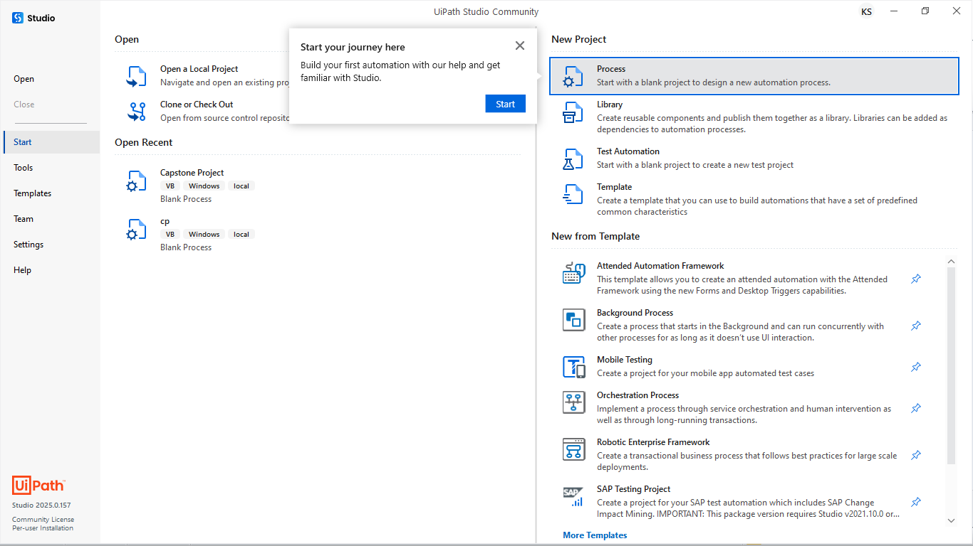

**Fig.6.1**

Step 2: The New Blank Process window is displayed

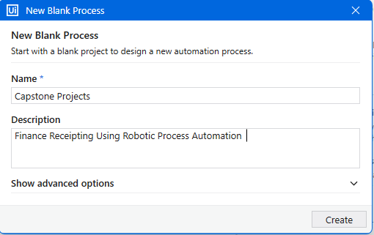

**Fig.6.2**

1. Enter a name for the new project and a description that summaries what you are aiming to do with this automation project.
2. Select the location where to create the project.
3. Click Create. The new project is opened in Studio.

Step 3: Install Packages

Open UiPath Studio and create a Transactional Process template, which is the best template for decision-based actions. Once the dependencies and workspace are created, click on Manage Packages on the Ribbon.

Now, click on All packages in the left pane and search for the package UiPath.word.Activities in the search box. Once it appears, click Install.

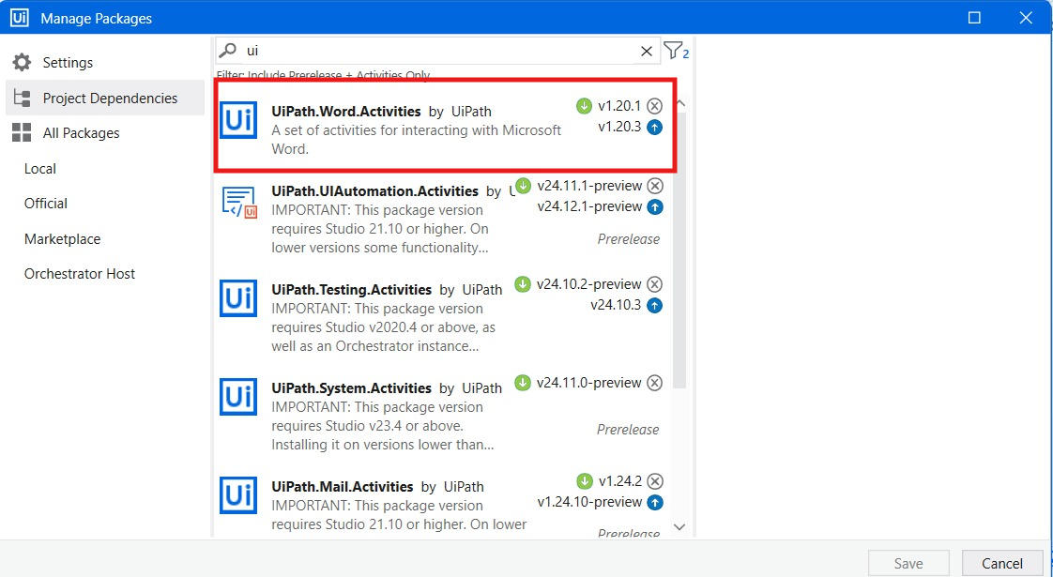

**Fig.6.3**

Step 4: Now, click on All packages in the left pane and search for the package “UiPath.Mail.Activities “ in the search box. Once it appears, click Install.

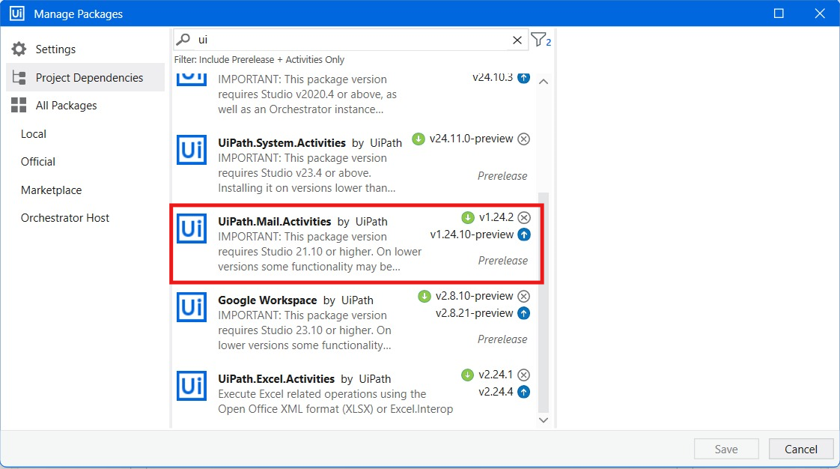

**Fig.6.4**

Step 5: Now, click on All packages in the left pane and search for the package “UiPath. Excel. Activities “in the search box. Once it appears, click Install.

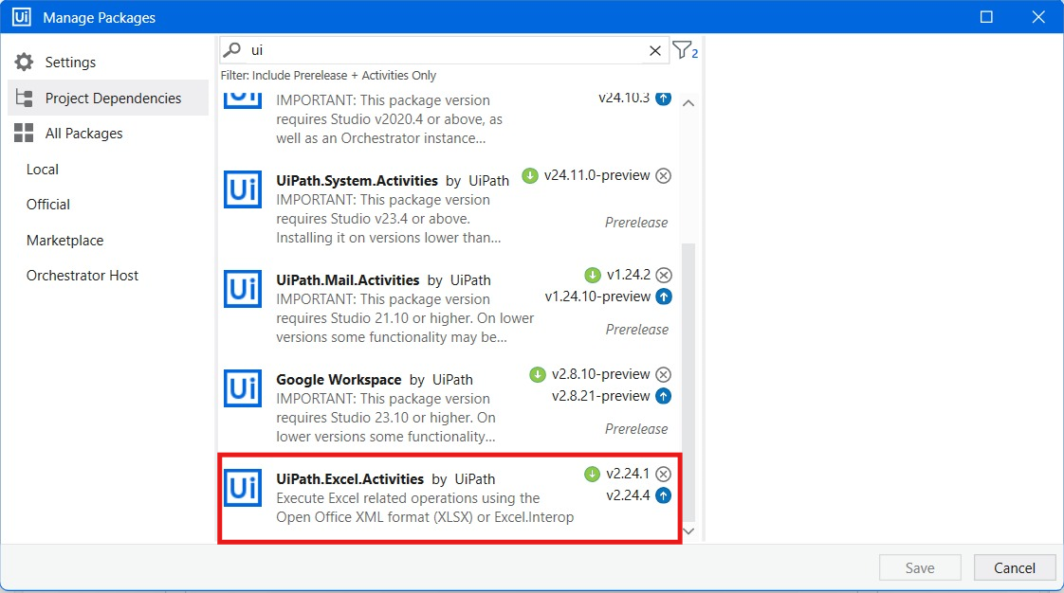

**Fig.6.5**

Step 6: Now, click on All packages in the left pane and search for the package “Google Workspace “in the search box. Once it appears, click Install.

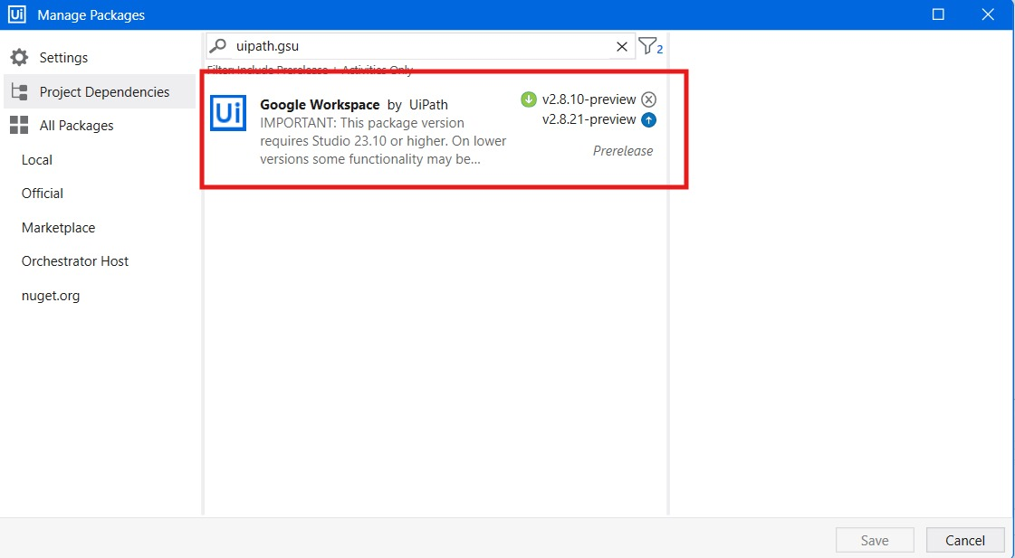

**Fig.6.6**

Step 7: The very first thing to do is drag and drop the “Excel Application Scope” in to the main sequence from the activities panel. And also add the location the Excel file location path stored in the device in the place of “Workbook path” (shown in the image7.2).

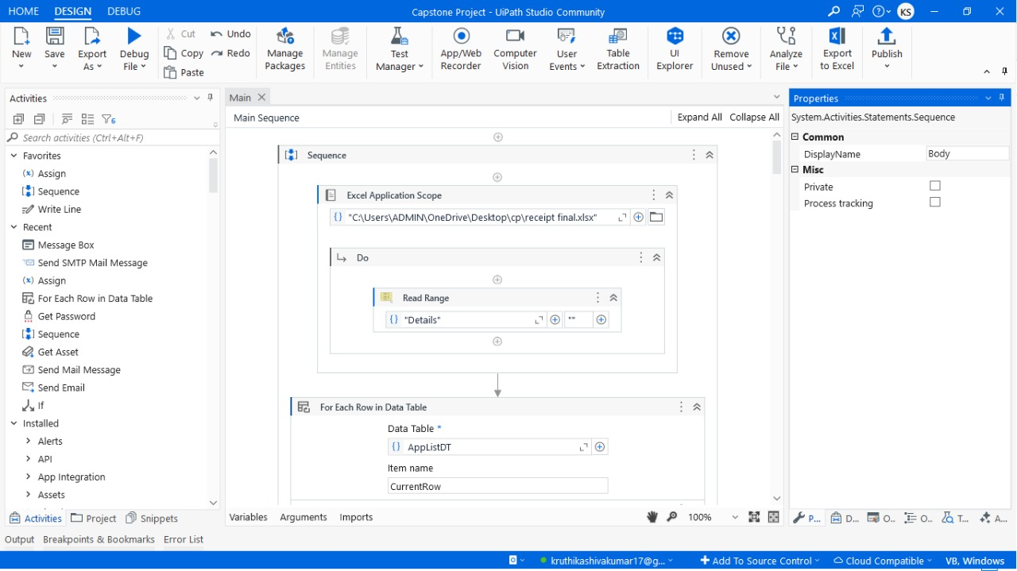

**Fig.6.7.1**

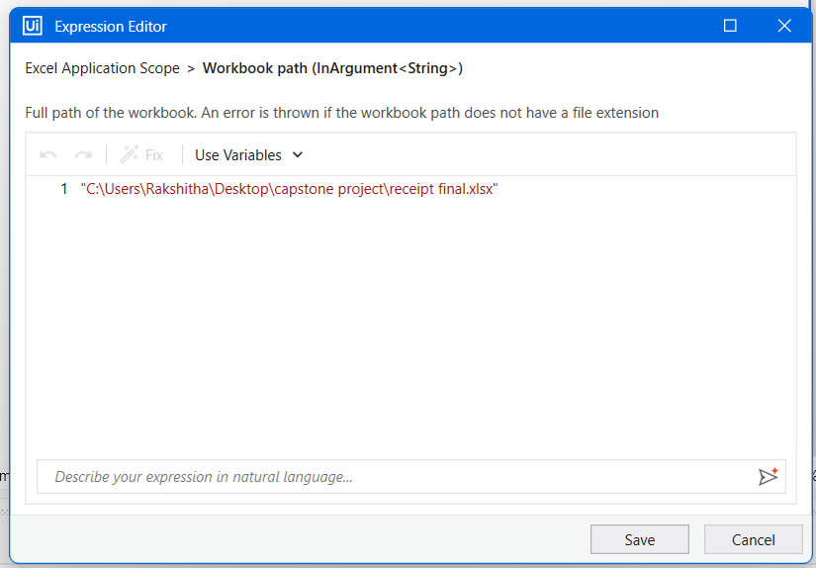

**Fig.6.7.2**

Step 8: Drag and drop the “Read Range Activity” in the place of “DO” in the “Excel Application Scope” and write your excel sheet name in the double quotes.



**Fig.6.8**

Step 9: Drag and drop the “For Each Row In Data Table” from the activity panel in to the main sequence.



**Fig.6.9**

Step 10: Create a new variable in the place of Data Table as “AppListDT” and in properties panel locate the Index field. Click on the empty space in the Index field, press Ctrl + K, and create a new variable named RowIndex_APPListDT.

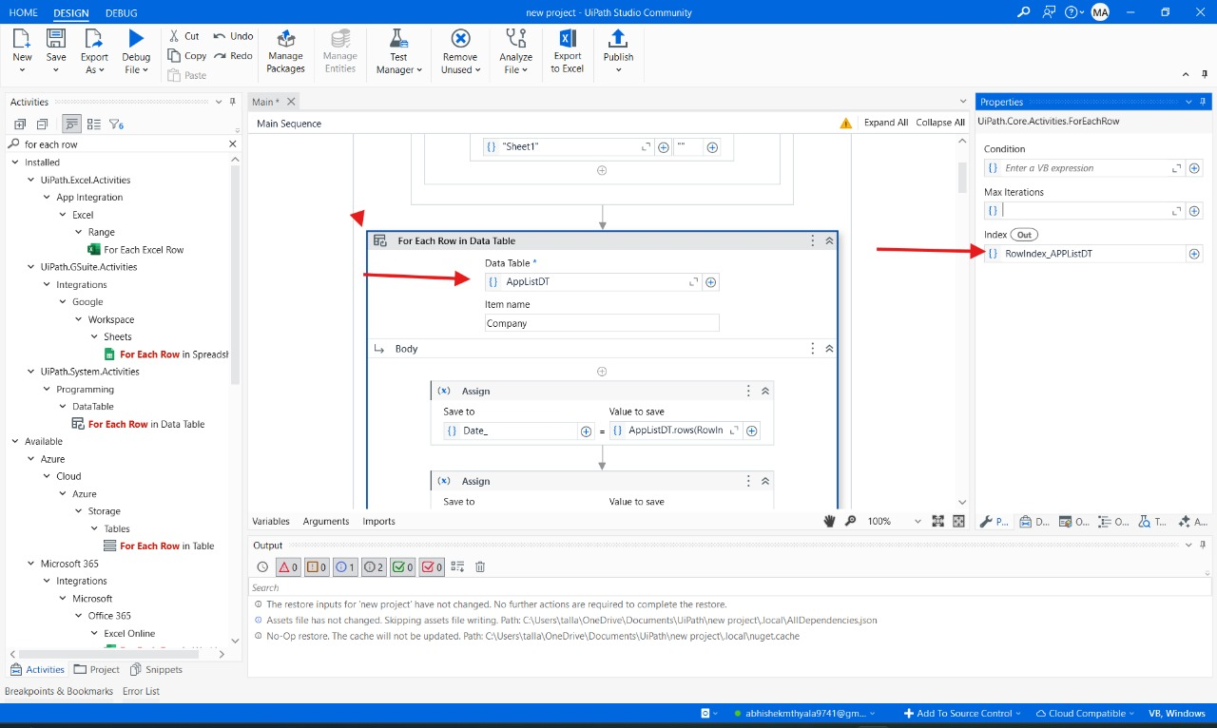

**Fig.6.10**

Step 11: Drag and drop the “Assign activity” from the activity panel and place in the body field of for Each row in the data table and in the field of save to create a variable called “Date_” and in the field of value to save write an expression “AppListDT.rows(RowIndex_AppListDT).item("Date").ToString”.

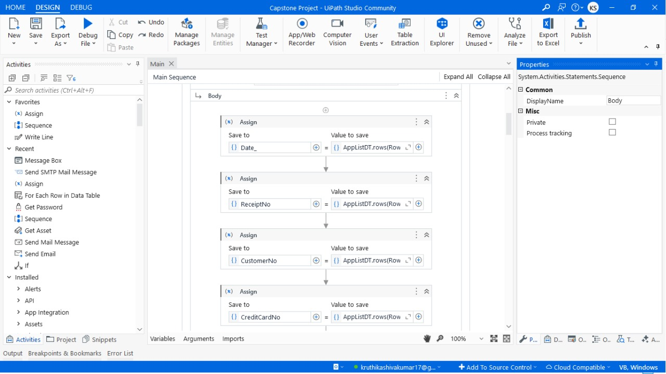

**Fig.6.11**

Step 12: Drag and drop the “Assign Activity” from the activity panel and place in the body field of for Each row in the data table and in the field of save to create a variable called “Receipt_No” and in the field of value to save write an expression “AppListDT.rows(RowIndex_AppListDT).item("Receipt No.").ToString”.



**Fig.6.12**

Step 13: Drag and drop the “Assign Activity” from the activity panel and place in the body field of for Each row in the data table and in the field of save to create a variable called “Customer_No” and in the field of value to save write an expression “AppListDT.rows(RowIndex_AppListDT).item("Customer No.").ToString”.



**Fig.6.13**

Step 14: Drag and drop the “Assign Activity” from the activity panel and place in the body field of for Each row in the data table and in the field of save to create a variable called “Card_No” and in the field of value to save write an expression “AppListDT.rows(RowIndex_AppListDT).item("Credit Card No.").ToString”.



**Fig.6.14**

Step 15: Drag and drop the “Assign Activity” from the activity panel and place in the body field of for Each row in the data table and in the field of save to create a variable called “Transaction_Id” and in the field of value to save write an expression “AppListDT.rows(RowIndex_AppListDT).item("Transaction ID").ToString”.

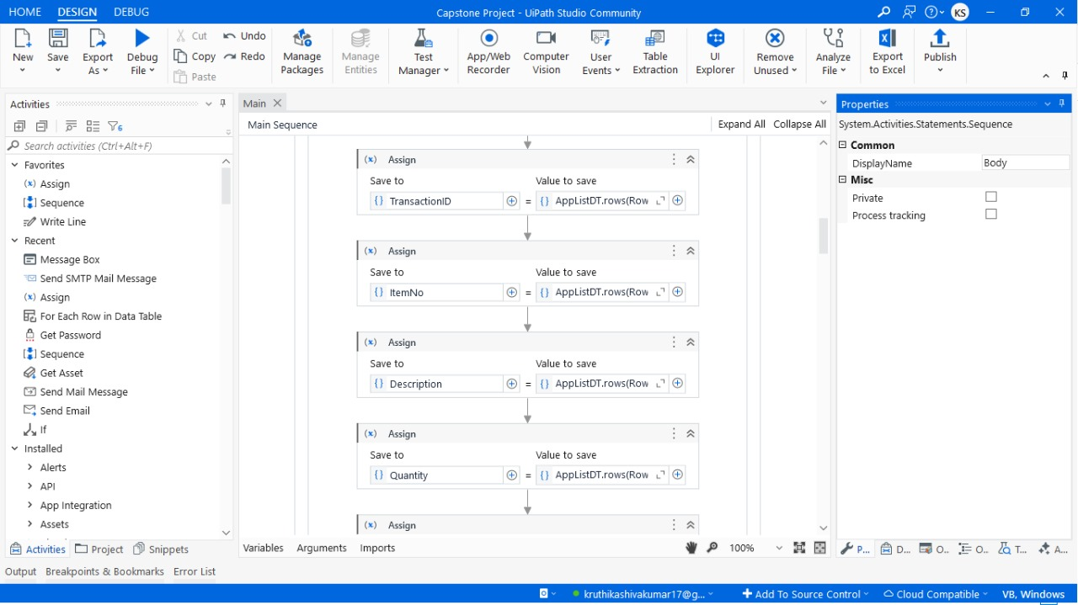

**Fig.6.15**

Step 16: Drag and drop the “Assign Activity” from the activity panel and place in the body field of for Each row in the data table and in the field of save to create a variable called “Item_No” and in the field of value to save write an expression “AppListDT.rows(RowIndex_AppListDT).item("Item No.").ToString”.



**Fig.6.16**

Step 17: Drag and drop the “Assign Activity” from the activity panel and place in the body field of for Each row in the data table and in the field of save to create a variable called “Description” and in the field of value to save write an expression “AppListDT.rows(RowIndex_AppListDT).item("Description").ToString”.



**Fig.6.17**

Step 18: Drag and drop the “Assign Activity” from the activity panel and place in the body field of for Each row in the data table and in the field of save to create a variable called “Quantity” and in the field of value to save write an expression “AppListDT.rows(RowIndex_AppListDT).item("Quantity").ToString”.



**Fig.6.18**

Step 19: Drag and drop the “Assign Activity” from the activity panel and place in the body field of for Each row in the data table and in the field of save to create a variable called “Unit_Price” and in the field of value to save write an expression “AppListDT.rows(RowIndex_AppListDT).item("Unit Price").ToString”.

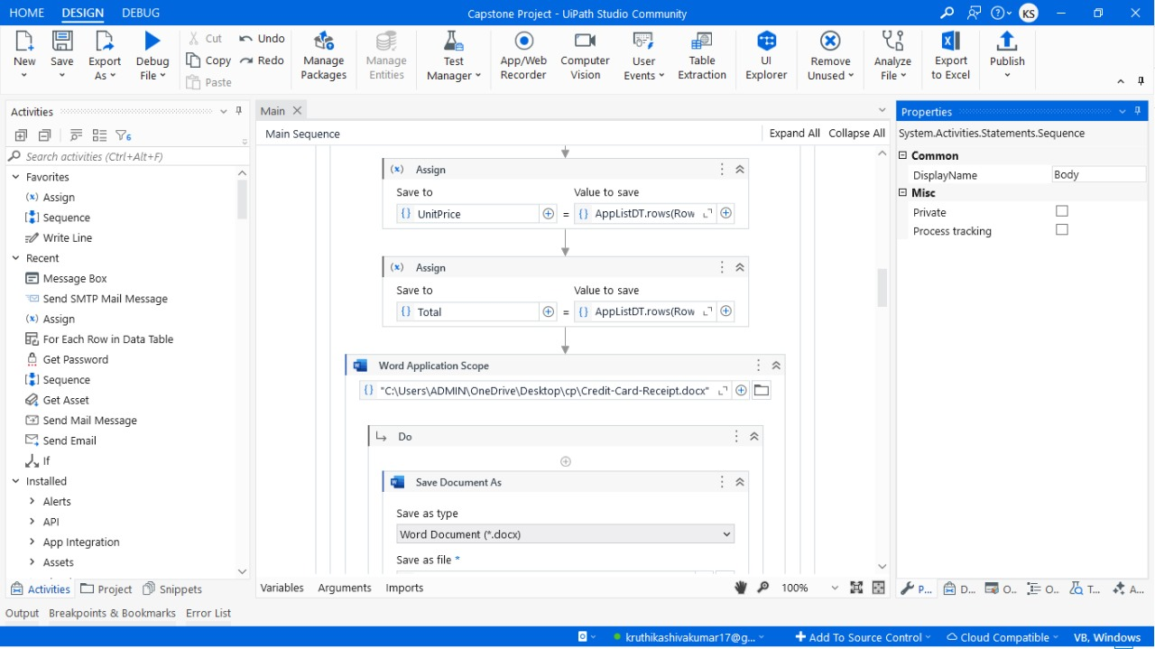

**Fig.6.19**

Step 20: Drag and drop the “Assign Activity” from the activity panel and place in the body field of for Each row in the data table and in the field of save to create a variable called “Total” and in the field of value to save write an expression “AppListDT.rows(RowIndex_AppListDT).item("Total").ToString”.



**Fig.6.20**

Step 21: Drag and drop the “Word Application Scope” in field of document path enter your Template Location Path.



**Fig.6.21**

Step 22: Drag and drop the “Save Document As Activity” from the activity panel and place in the DO filed of “Word Application Scope”.In save document as activity find save as file field and enter the location path where the files should be saved.



**Fig.6.22**

Step 23: Drag and drop the “Replace Text In Document Activity” from the activity panel and place in the DO filed of “Word Application Scope”. In Replace Text In Document Activity find search for filed and enter “Date_ex”. And in the place of replace with filed enter the variable “Date_”.

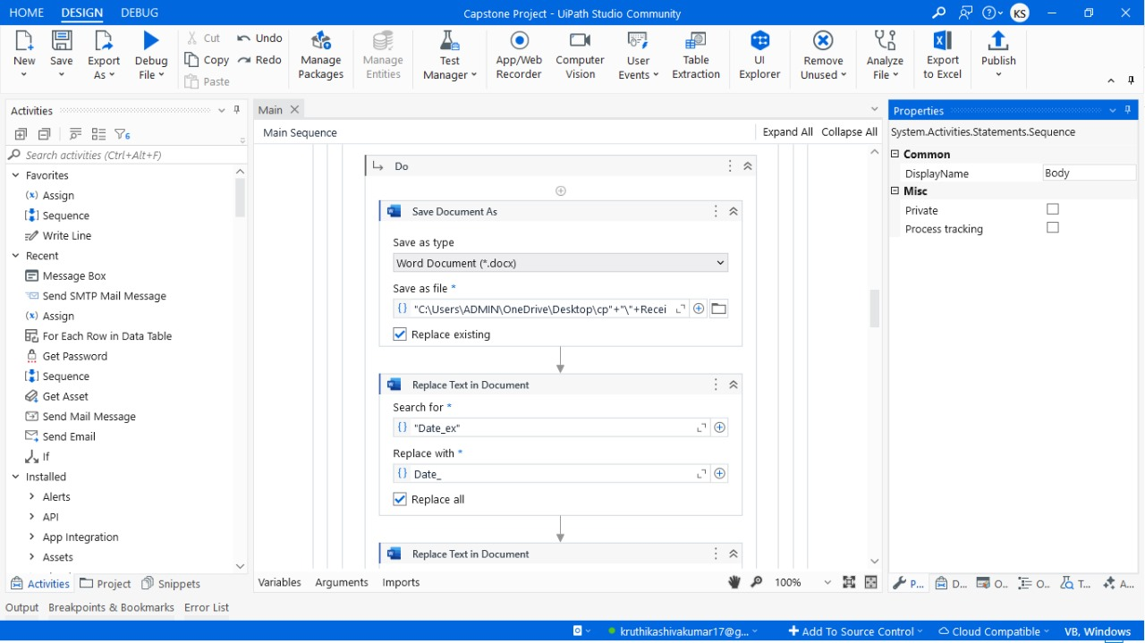

**Fig.6.23**

Step 24: Drag and drop the “Replace Text In Document Activity” from the activity panel and place in the DO filed of “Word Application Scope”. In Replace Text In Document Activity find search for filed and enter “Receipt_ex”. And in the place of replace with filed enter the variable “Receipt_No”.

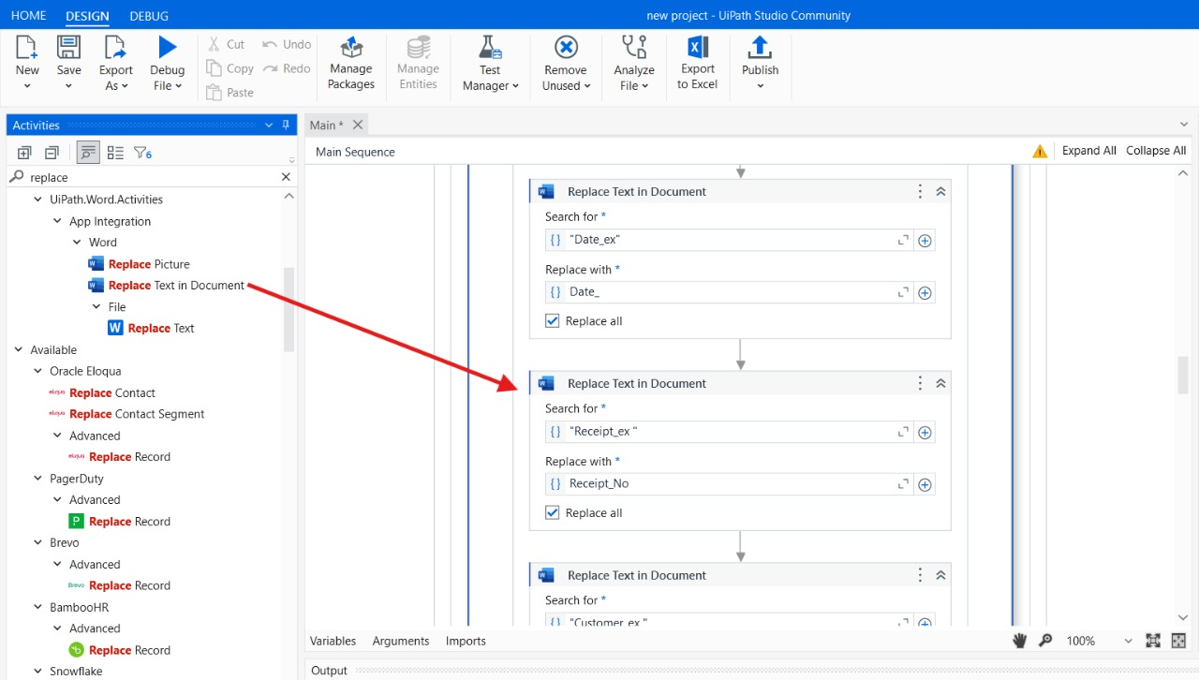

**Fig.6.24**

Step 25: Drag and drop the “Replace Text In Document Activity” from the activity panel and place in the DO filed of “Word Application Scope”. In Replace Text In Document Activity find search for filed and enter “Customer_ex”. And in the place of replace with filed enter the variable “Customer_No”.

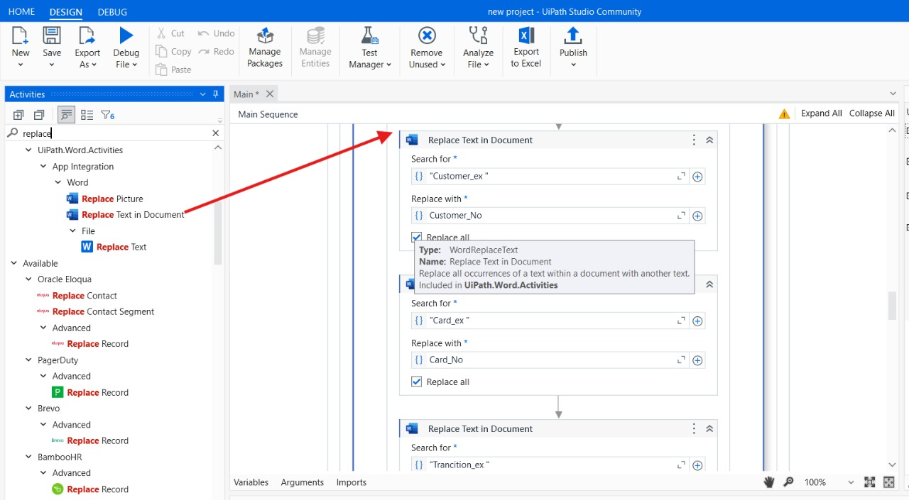

**Fig.6.25**

Step 26: Drag and drop the “Replace Text In Document Activity” from the activity panel and place in the DO filed of “Word Application Scope”. In Replace Text In Document Activity find search for filed and enter “Card_ex”. And in the place of replace with filed enter the variable “Card_No”.

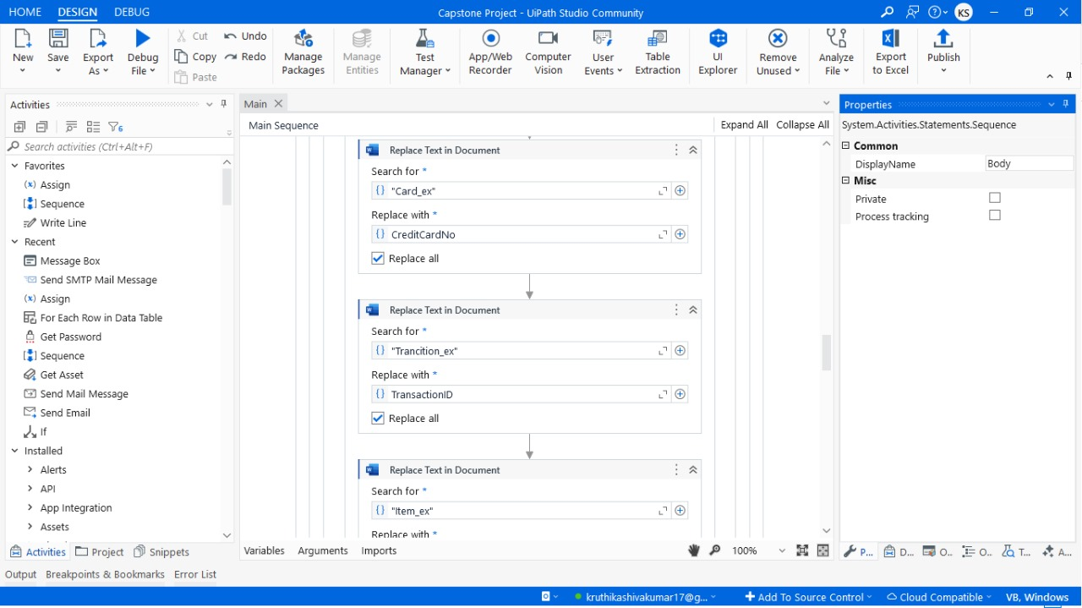

**Fig.6.26**

Step 27: Drag and drop the “Replace Text In Document Activity” from the activity panel and place in the DO filed of “Word Application Scope”. In Replace Text In Document Activity find search for filed and enter “Transation_ex”. And in the place of replace with filed enter the variable “Transation_Id”.



**Fig.6.27**

Step 28: Drag and drop the “Replace Text In Document Activity” from the activity panel and place in the DO filed of “Word Application Scope”. In Replace Text In Document Activity find search for filed and enter “Item_ex”. And in the place of replace with filed enter the variable “Item_No”.



**Fig.6.28**

Step 29: Drag and drop the “Replace Text In Document Activity” from the activity panel and place in the DO filed of “Word Application Scope”. In Replace Text In Document Activity find search for filed and enter “Description_ex”. And in the place of replace with filed enter the variable “Description”.

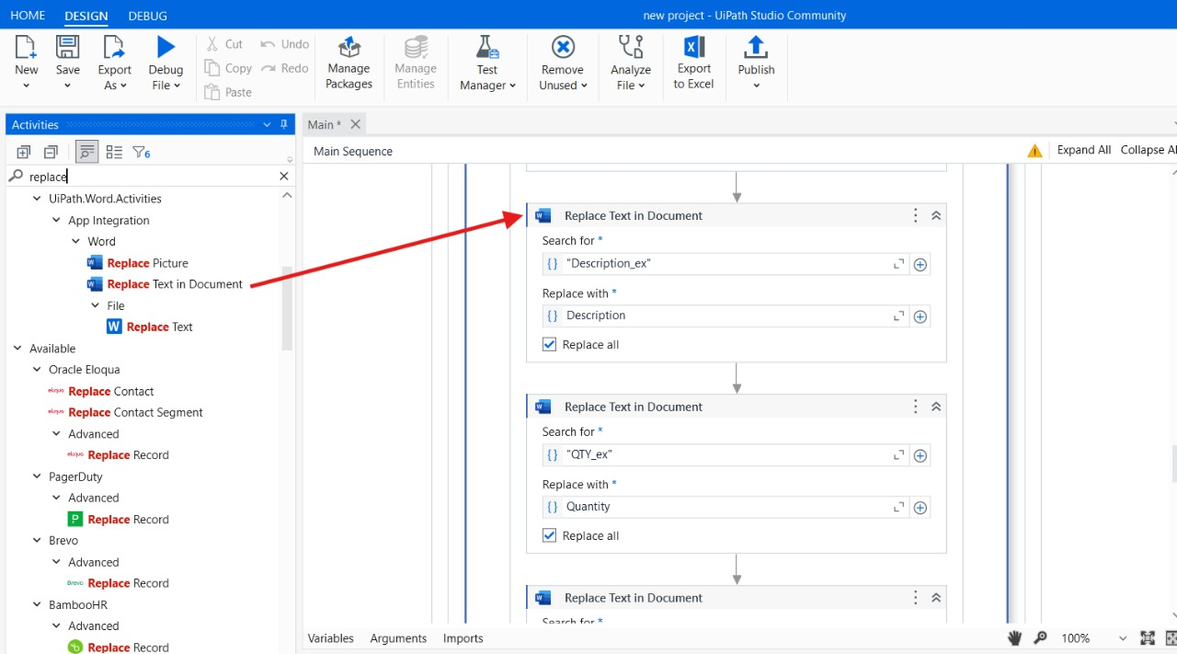

**Fig.6.29**

Step 30: Drag and drop the “Replace Text In Document Activity” from the activity panel and place in the DO filed of “Word Application Scope”. In Replace Text In Document Activity find search for filed and enter “QTY_ex”. And in the place of replace with filed enter the variable “Quantity”.

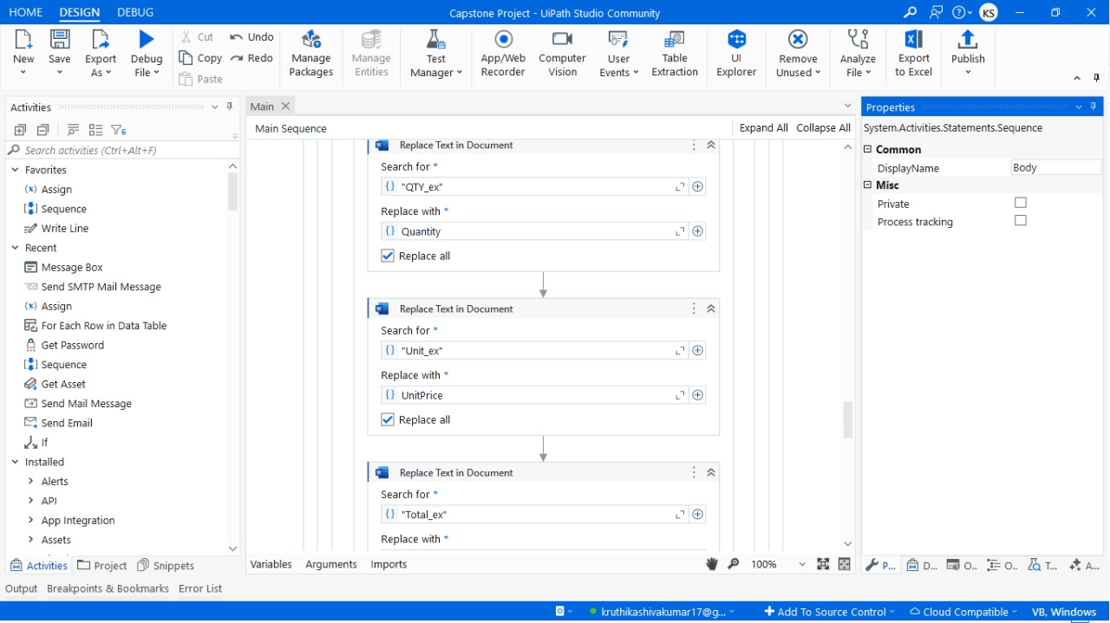

**Fig.6.30**

Step 31: Drag and drop the “Replace Text In Document Activity” from the activity panel and place in the DO filed of “Word Application Scope”. In Replace Text In Document Activity find search for filed and enter “Unit_ex”. And in the place of replace with filed enter the variable “Unit_Price”.



**Fig.6.31**

Step 32: Drag and drop the “Replace Text In Document Activity” from the activity panel and place in the DO filed of “Word Application Scope”. In Replace Text In Document Activity find search for filed and enter “Total_ex”. And in the place of replace with filed enter the variable “Total”.

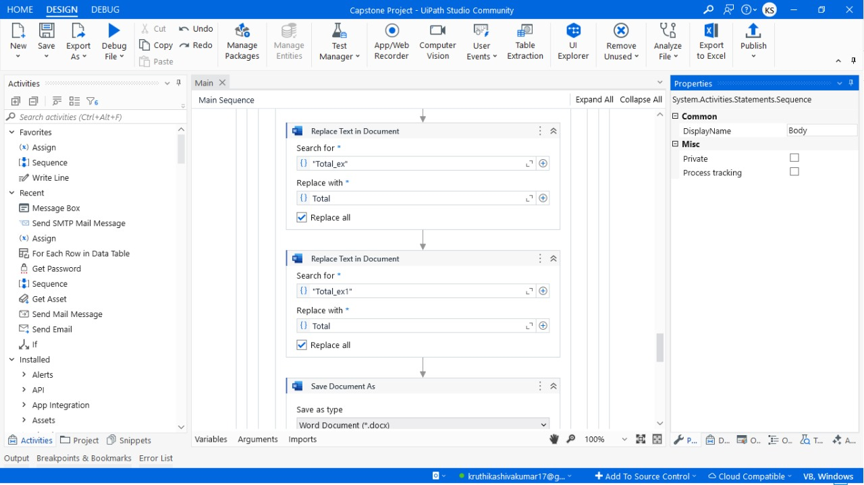

**Fig.6.32**

Step 33: Drag and drop the “Save Document As Activity” from the activity panel and place in the DO filed of “Word Application Scope”.In save document as activity find save as file field and enter the location path where the files should be saved.



**Fig.6.33**

Step 34: Drag and drop the “Send SMTP Mail Message” from the activity panel and in the gmail filed connect to your gmail in “To” filed enter a variable “{email}” and enter your subject and body in the attachments filed locate your saved file location path.

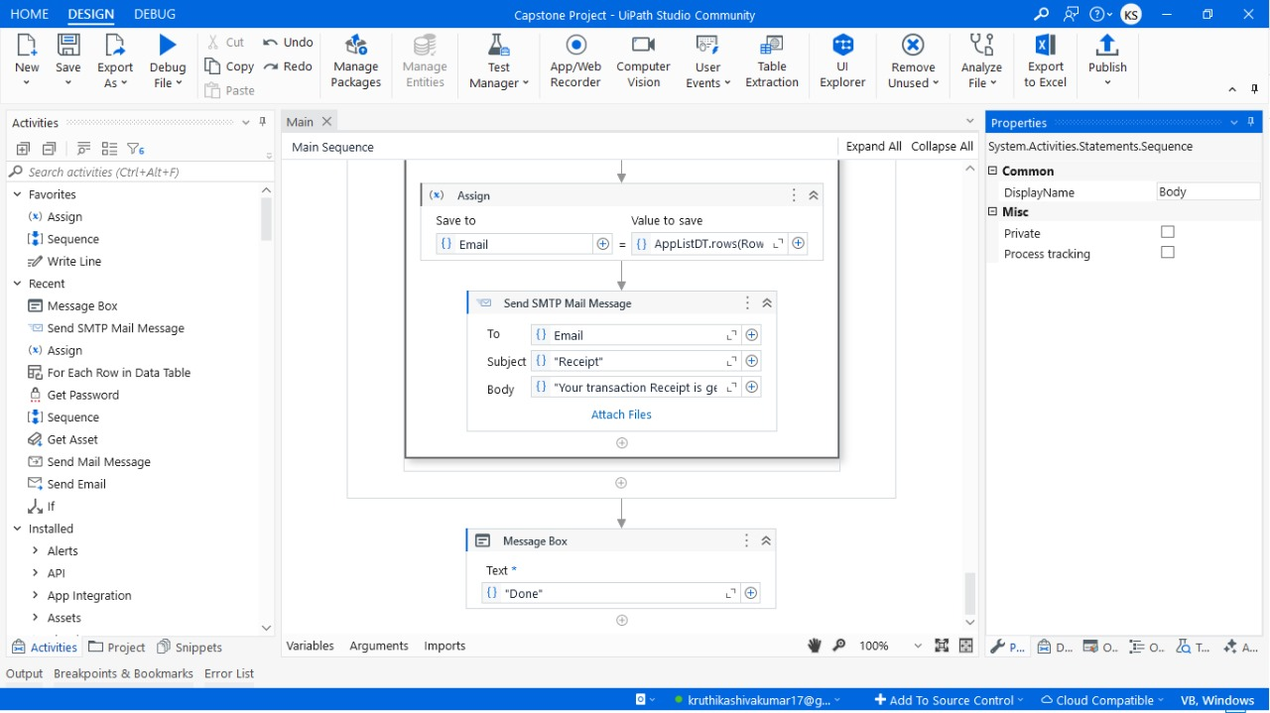

**Fig.6.34**

**CHAPTER-7**

**TIMELINE FOR EXECUTION OF PROJECT**

**(GANTT CHART)**

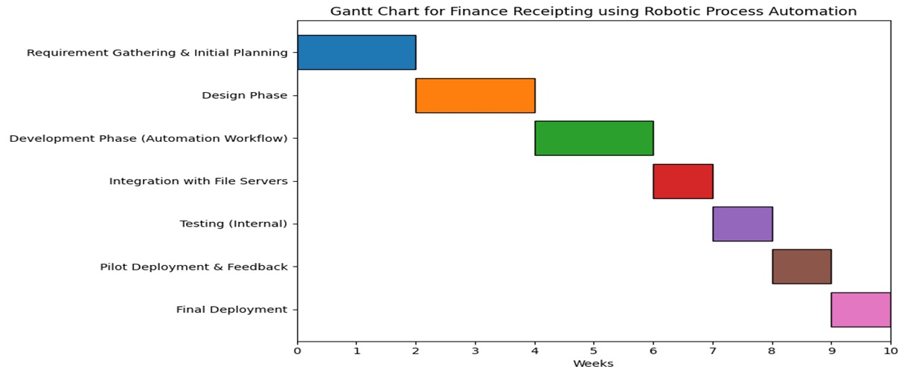

**Fig.7.1 GANTT CHART**

**CHAPTER-8**

**OUTCOMES**

Automating an automated finance receipting system in UiPath enhances the operational efficiency of the overall processes implemented. Automating data extraction and receipt generation from emails reduces a lot of the time taken on transactions, giving businesses the power to process several transactions at very high speeds with efficiency. These streamlined workflows thus eliminate bottlenecks and always guarantee consistent performances even during peak transactions.

The system eradicates manual entry of data and population of templates, thus it improves accuracy significantly by reducing financial receipts errors. Such accuracy helps maintain the integrity of financial records while building the trust of the customer through delivering error-free documentation. Besides, automated file management saves receipts in a systematic order, thus enhancing record-keeping and preparing them for auditing.

The other major output of the system is scalability. Because businesses are expanding in size and therefore, transactions, the automated solution can handle increased workloads without extra resources or human intervention. This will make the system future-proof to support long-term business growth.

The cost will be reduced based on the number of manual dependencies reduced, cheaper labor, and costs associated with errors or the delay in correcting or managing them. The automation for sending emails sends the receipts quickly to the customer, thus having better satisfaction rates and communication regarding the clients.

The system includes strong error-handling and logging mechanisms, so it can work smoothly even in the presence of errors such as missing data or invalid email addresses. These features enable quick identification and resolution of errors without disrupting the overall workflow.

Lastly, the system ensures the handling of customer sensitive data is handled in a secure fashion. This includes abiding by data protection regulations like GDPR or PCI-DSS, which minimizes the exposure of resulting data breaches and ensures compliance on reputation value for customers.

**CHAPTER-9**

**RESULTS AND DISCUSSIONS**

The implementation of RPA in finance receipting is expected to produce several positive outcomes. First, the automation of data extraction and receipt generation will significantly reduce the time required to process transactions, leading to faster turnaround times and improved efficiency. Second, by eliminating manual data entry, the system will improve accuracy, reducing the risk of errors in receipts and financial records. Third, the automation of email distribution ensures that customers receive their receipts promptly, improving customer satisfaction. Additionally, the system will be scalable, allowing businesses to handle increasing transaction volumes without additional resources. Finally, the project will ensure that customer data is handled securely, in compliance with data protection regulations.

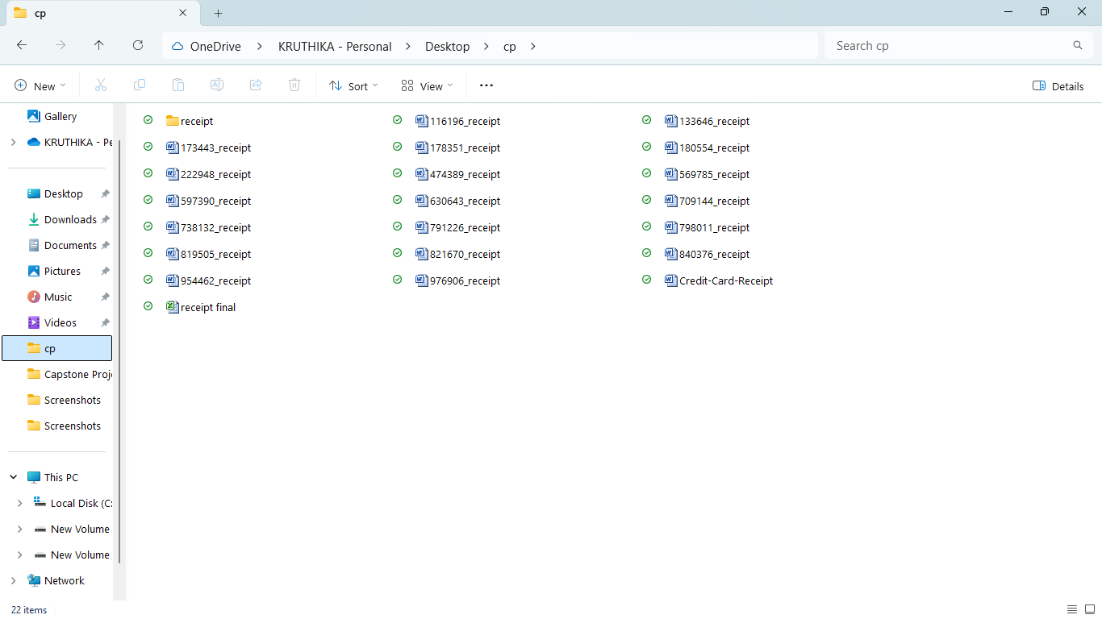

**Fig.9.1**

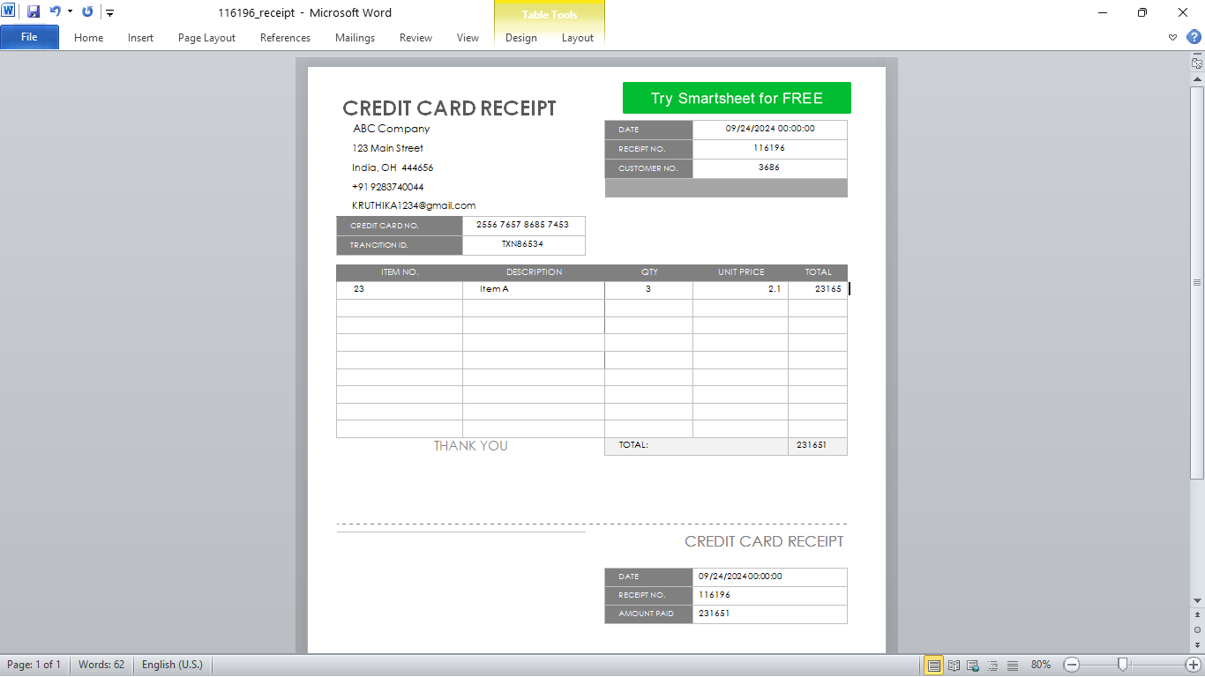

**Fig.9.2**

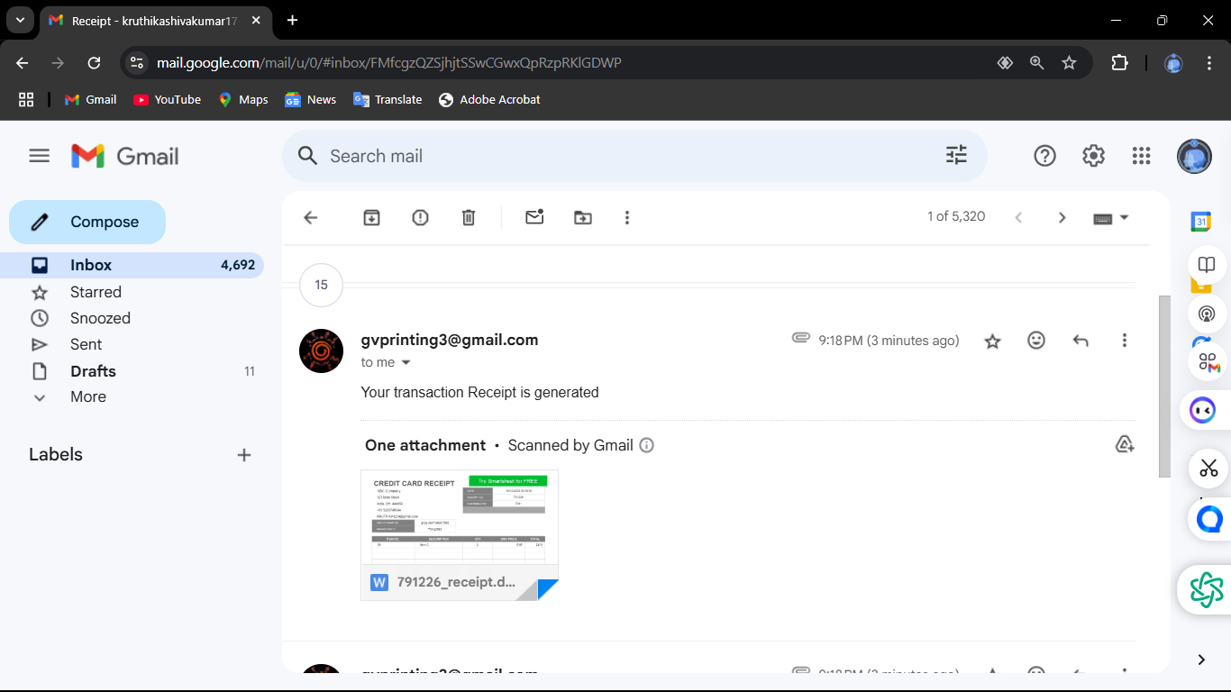

**Fig.9.3**

**CHAPTER-10**

**CONCLUSION**

This marks the big step that marks the address in inefficiency and challenges experienced using traditional processes involving manual inputs into the implementation of an automated finance receipting system using UiPath. With an automated task set including data extraction, generation of receipts, handling of files, and dispatching via e-mail, these workflows can then be made effective with time-to-process being saved and minimal opportunities for errors in general.

Besides this, its adaptability and error-handling capabilities make the system scalable to suit future needs, and strong security measures assure better protection of customers' sensitive data against any regulations and fraudsters, thus helping the business be reliable and trusted. The automated repetitive task reduction project minimizes cost by reducing labor time spent on doing tasks that would be repetitive while helping businesses utilize resources on strategy-driven initiatives.

In summary, this project shows the true RPA potential in financial operations as it offers a realistic, efficient, and scalable finance receipting solution. It lays a strong foundation for businesses that are on their way to embracing automation and optimizing their back-office processes for sustained success and customer satisfaction.

**REFERENCES**

[1] Chan, S.W.S., Ip, S., Wan, C.F.C., Yiu, H.F.D. (2021). How would the emerging technology affect the future of auditing? Outstanding Academic Papers by Students (OAPS), City University of Hong Kong. <http://dspace.cityu.edu.hk/handle/2031/9133>.

[2] Cohen, M., Rozario, A.M., Zhang, C.A. (2019). Exploring the Use of Robotic Process Automation (RPA) in Substantive Audit Procedures: A Case Study. CPA Journal, July.

[3] Issac, R., Muni, R., & Desai, K. (2018). Delineated Analysis of Robotic Process Automation Tools. 2018 Second International Conference on Advances in Electronics, Computers and Communications (ICAECC), Bangalore, pp. 1-5. doi: 10.1109/ICAECC.2018.8479511.

[4] KPMG (2020). RPA in Internal Audit: Emerging Trends and Applications. <https://home.kpmg/xx/en/home/insights/2020/06/rpa-internal-audit.html>.

[5] Deloitte (2019). Robotic Process Automation for Audit: A Game Changer for the Future of Auditing. [https://www2.deloitte.com/insights/us/en/topics/digital-transformation/robotic-process-automation-audit.html.](https://www2.deloitte.com/insights/us/en/topics/digital-transformation/robotic-process-automation-audit.html.%20)

[6] Rozario, A. M., & Vasarhelyi, M. A. (2018). How RPA is Transforming the Auditing Process. Journal of Emerging Technologies in Accounting, 15(2), 37–46.

[7] PWC (2017). The Impact of Automation on Auditing: Moving Forward with RPA. <https://www.pwc.com/gx/en/services/assurance/the-impact-of-automation-on-audit.html>.

[8] Lacity, M. C., & Willcocks, L. P. (2018). Robotic Process Automation and Risk Mitigation in Auditing. Journal of Information Technology, 33(2), 81-98.

<https://www.uipath.com/resources/automation-case-studies>.

[10] Deloitte (2023). Delivering Breakthrough Outcomes Through Intelligent Automation. This publication discusses how intelligent automation drives business efficiency and innovation. Retrieved from <https://www2.deloitte.com/us/en.html>.

[11] Ernst & Young (2022). The Role of RPA in Financial Receipting Workflows. This report highlights the benefits of RPA in streamlining receipting processes. Retrieved from <https://www.ey.com/en_gl>.

[12] Forrester (2022). Scaling Financial Automation with RPA: Challenges and Opportunities. This research identifies challenges and strategies for scaling RPA in financial operations. Accessed at <https://go.forrester.com/research/>.

[13] Accenture (2022). The Future of Financial Automation. This article provides insights into the evolving landscape of financial automation. Retrieved from <https://www.accenture.com/us-en>.

[14] PWC (2023). Strategic RPA Adoption in Financial Services. This study focuses on strategies for integrating RPA into financial workflows effectively. Retrieved from <https://www.pwc.com/gx/en/services/assurance.html>.

[15] McKinsey & Company (2023). Digital Transformation and RPA. This report examines how digital transformation leverages RPA to optimize operations. Accessed at <https://www.mckinsey.com/>.

[16] Gartner (2022). RPA Trends in Financial Processes. This publication highlights emerging trends and innovations in RPA for financial services. Retrieved from <https://www.gartner.com/en>.

[17] UiPath Blog (2023). RPA Best Practices in Finance. This blog discusses key practices to maximize the benefits of RPA in financial processes. Retrieved from <https://www.uipath.com/blog>.

[18] IBM (2023). Implementing RPA in Financial Workflows. This guide outlines best practices for deploying RPA in finance. Retrieved from <https://www.ibm.com/cloud>.

[19] Capgemini (2022). RPA in Banking and Finance. This report discusses the integration of RPA in banking to enhance efficiency and compliance. Accessed at [https://www.capgemini.com](https://www.capgemini.com/).

[20] Harvard Business Review (2022). Automation in Finance: Balancing Efficiency and Security. This article explores how financial automation balances operational efficiency with security. Retrieved from <https://hbr.org/>

**ENCLOSURES**

**1.Journal publication Paper Presented Certificates of all students.**

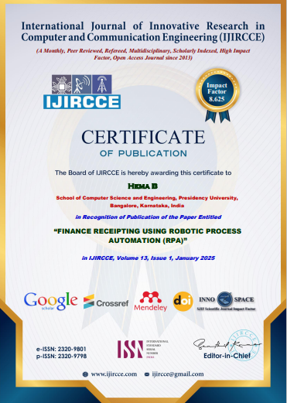

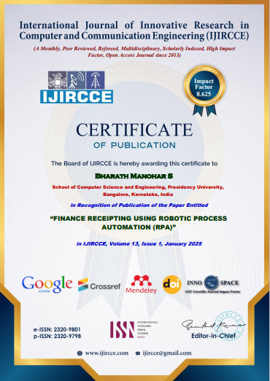

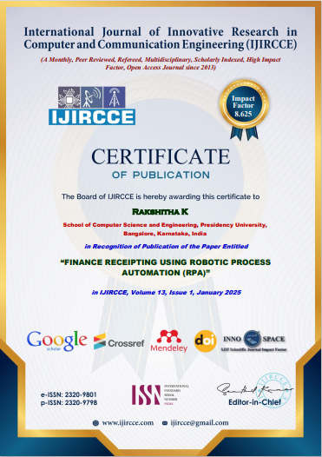

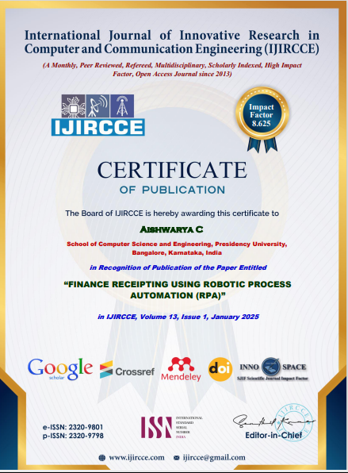

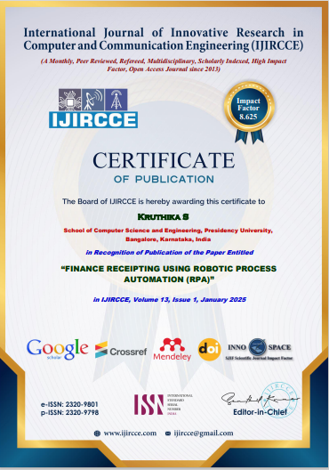

**2.****Details of mapping the project with the Sustainable Development Goals (SDGs).**



SDG 8: Decent Work and Economic Growth  
  
RPA amplifies productivity by getting rid of redundant labor-in fact, freeing the workforce to upskill into more strategic positions.  
  
SDG 12: Responsible Consumption and Production  
  
Automating the receipting processes of finance removes paper-based workflows and encourages efficient resource utilization.  
  
SDG 13: Climate Action  
  
Lower physical infrastructure requirements in terms of file cabinets and storage decrease the carbon footprint resulting from office functions.  
  
SDG 9: Industry, Innovation and Infrastructure RPA drives innovation and reinforces digital infrastructure for sustainable industrial processes.